Name - Alshifana.B

B.Tech - Artificial Intelligence and Data Science , Final Year

AI related course work / project / experience  
**PLEase update github**

# Milestone 1 - completed

# Milestone 2:

**U-Net (Semantic Segmentation – Ruins & Vegetation)**

* Training Images: 464 ,Validation Images: 116
* Mean Validation Dice Coefficient: 0.5926
* Mean Validation IoU: 0.5869

**YOLO(Object classification – Archaeological Structures)**

## **Precision:** **0.909**

## **Recall:** **0.0749**

## **mAP@0.5:** **0.103**

## Classes: ['coin', 'jewelry', 'pottery', 'sculpture', 'seal', 'tablet', 'weapon'] # class names

# Milestone 3

Dataset:

• Total samples: 580

• Training samples: 464

• Validation samples: 116

* **Root Mean Squared Error (RMSE):** 0.0024
* **R-squared (R² Score):** 1.0000

**Milestone 1: Dataset Collection and Preparation (Weeks 1–2)**

# **Week 1 - Day 1**

### Findings:

I explored several dataset sources and also experimented with creating a custom dataset manually. Using Google Earth Pro, I extracted sample satellite images and attempted annotation through LabelBox and QGIS to understand the workflow. Through this process, I gained understanding of the types of datasets required for this project.

From my review, the project needs three major categories of data:

1. Segmentation datasets (for identifying ruins, vegetation, soil, and other land-cover types)
2. Artifact detection datasets (for detecting and classifying archaeological structures or objects)
3. Erosion prediction datasets (terrain, elevation, and environmental layers)

I also downloaded and examined an open-source dataset, DeepGlobe Land Cover Dataset, available on Kaggle. This dataset helped me understand how satellite imagery is annotated and labeled for segmentation tasks. It includes raw satellite images along with their corresponding segmentation masks, which was useful for studying annotation formats and preprocessing approaches.

Based on these observations, the project will require a similar structure:

* Raw satellite or drone images that contain archaeological features such as artifacts, vegetation, ruins, and soil patterns.
* Corresponding labeled and segmented masks for each raw image, covering all relevant classes needed for training.

We still need project-specific imagery that accurately represents our archaeological use case, along with properly annotated segmentation masks and detection labels to support all three modeling tasks.

# **Week 1 – Day 2**

## **Data Source Reference**

### **1. Sentinel-2 L2A (Level-2A – Bottom-of-Atmosphere Reflectance)**

#### **Source :** Copernicus Data Space Ecosystem

#### **Description**

The Sentinel-2 L2A dataset provides **atmospherically corrected multispectral imagery** ideal for:

* Land-cover mapping
* Vegetation monitoring
* Surface feature extraction

It contains **13 spectral bands** spanning the visible, near-infrared, and short-wave infrared regions.

### **Dataset Link**

<https://browser.dataspace.copernicus.eu/?zoom=15&lat=-11.44938&lng=-76.59336&themeId=DEFAULT-THEME&visualizationUrl=U2FsdGVkX18yIRGveZdBIahVctGqrxwF1pO01BAkIFSGKlVzOCdU2RMn8cjsEvn0099JWMl5dp%2Bpc87fqGZ523OK78Bll1iEXxV%2BmNORzUaA0%2F0t%2F4%2FynNzlMsACbI%2Fj&datasetId=S2_L2A_CDAS&demSource3D=%22MAPZEN%22&cloudCoverage=30&dateMode=SINGLE>

### **2. Vegetation Dataset – Findings & Access Summary**

#### **Source :** Terrascope Platform

#### **URL:**

<https://viewer.terrascope.be/?language=en&bbox=-1.4695931290646036,49.05514501157924,10.699117937070442,52.436554469607586&overlay=true&bgLayer=OSM&date=2025-12-02&layer=terrascope-s2-toc-v2_tci>

### **Overview**

Terrascope is an open-access **Earth Observation (EO) platform** offering processed satellite datasets from **Sentinel-2**, **PROBA-V**, and **SPOT-VEGETATION**. The platform supports vegetation-related studies. Users can visually explore data layers and download scientific products directly through the viewer.

### **Dataset Identified**

The provided link corresponds to the **Sentinel-2 TOC (Top-of-Canopy) V2** dataset displayed as a **True Color Image (TCI)**.  
 This product is atmospherically corrected and suitable for **vegetation assessment** and **land-cover interpretation**.

**Source Sensor and Data**

* **Sensor:** Sentinel-2 MSI (MultiSpectral Instrument)
* **Data Type:** TOC reflectance (Bottom-of-Atmosphere corrected)
* **Spatial Resolution:** 10 m
* **Visualization:** True Color Composite (RGB)

**Key Findings/Applications**

* Vegetation cover analysis
* Land-cover and land-use classification
* Mapping forests, agricultural areas, and green zones
* Temporal vegetation monitoring (multi-date analysis)

# **Week 1 – Day 3**

I explored targeted sites—such as Chan Chan (Peru), Petra (Jordan), and Normanton Down Barrows (UK)—to better understand the characteristics of satellite imagery regarding ruins, surface artifacts, and landscape features. These locations were selected to serve as "Ground Truth" for training the three distinct AI models.I also explored the necessary image resolutions, specifically the Ground Sample Distance (GSD) required for detecting different archaeological features. My findings on the technical specifications are detailed below:

| **Target Feature** | **Required Resolution** | **Recommended Sensor** |
| --- | --- | --- |
| **Surface Artifacts (Pottery/Debris)** | < 5 cm / pixel | Low-altitude Drone (OpenAerialMap) |
| **Stone Walls & Ruins** | 10 cm - 50 cm / pixel | High-Res Satellite / Drone |
| **Burial Mounds / Earthworks** | 0.5 m - 1 m / pixel | Maxar / Google Earth / Aerial |
| **Landscape / Erosion Risk** | 10 m - 30 m / pixel | Sentinel-2 (Optical) / SRTM (DEM) |

**Key Finding on Dimensions:** The total image dimension (e.g., 1485x892) is secondary to the **resolution**. A target object must occupy **50-100 pixels** in width within the tiled input for the Neural Network to detect it successfully.

**Sample Images:**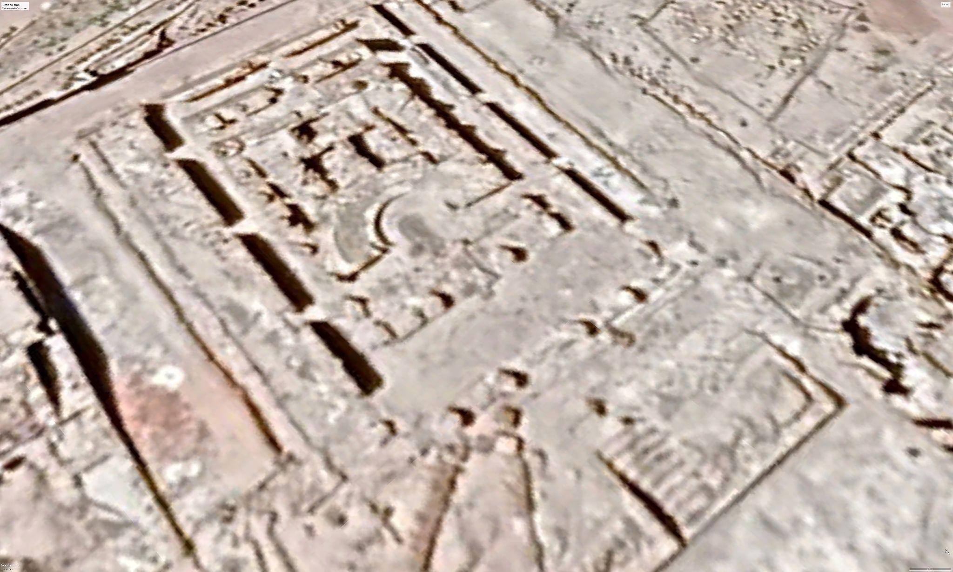

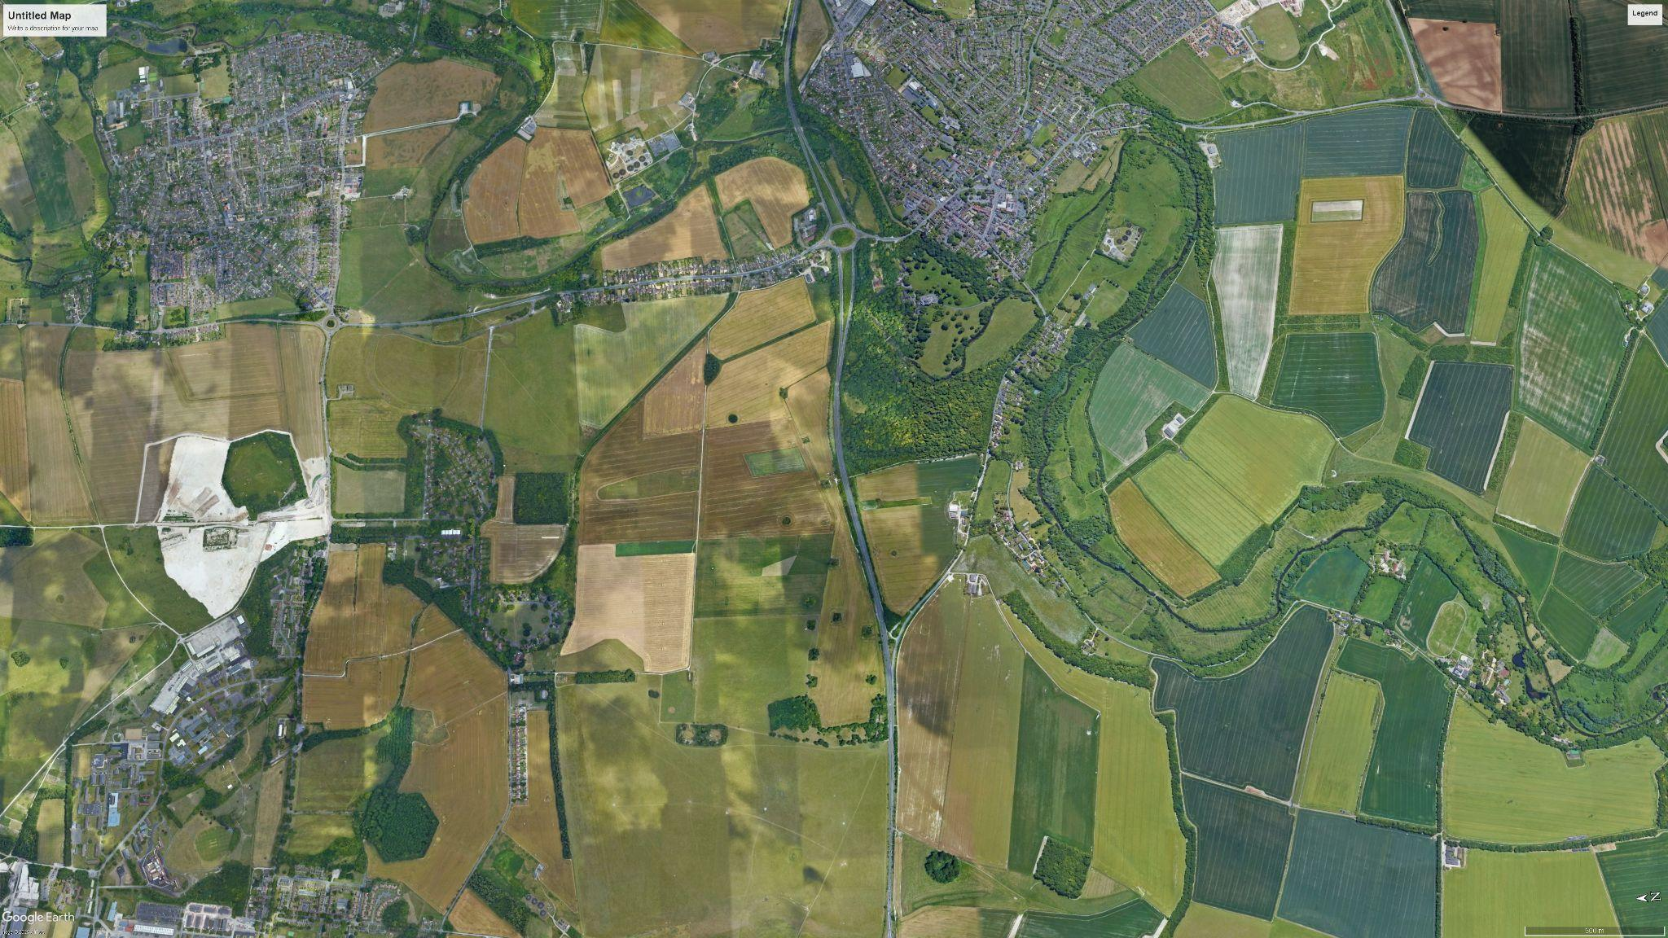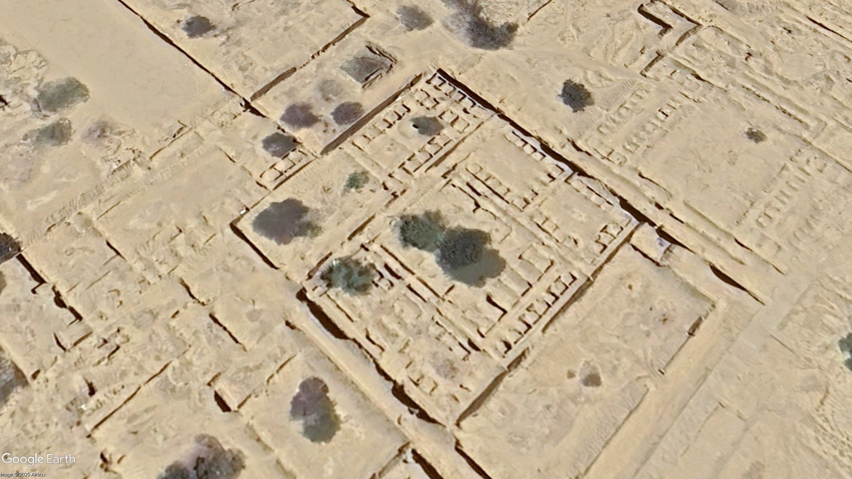

# **Week 1 - Day 4**

The aim of this project is to perform semantic segmentation of satellite imagery to identify classes such as ruins and vegetation using deep learning architectures like U-Net and DeepLabV3+. During Week 1, the focus was placed on gaining familiarity with the tools and theoretical concepts required for dataset preparation and model development.

## **1. Exploration of Google Earth Pro**

A key task for this week was to understand how to acquire satellite imagery from **Google Earth Pro**, which will serve as the primary data source for this project. I explored the interface in depth, including how to:

* Navigate to target archaeological regions using coordinates
* Adjust camera tilt, orientation, and zoom levels
* Evaluate image clarity and suitability for segmentation
* Test the “Save Image” options and understand export settings

I attempted capturing sample images from several targeted archaeological areas to understand the expected resolution, variations in terrain, and challenges such as label overlays, perspective distortion, and the need for consistent view settings. This exploration helped me understand the practical considerations involved in assembling a training dataset.

## **2. Study of Deep Learning Concepts**

As instructed, I reviewed essential deep learning concepts to build a conceptual foundation for upcoming tasks. I studied:

* **Semantic segmentation:** the pixel-wise classification approach used for extracting ruins, vegetation, and other classes
* **U-Net architecture:** an encoder-decoder network with skip connections designed for medical and satellite image segmentation
* **DeepLabV3+:** a more advanced architecture using various convolutions and multi-scale feature extraction
* **Loss functions:** including Categorical Cross-Entropy and Dice Loss, and their role in evaluating segmentation accuracy

This theoretical preparation has helped me understand why these models are suitable for satellite image segmentation and what requirements they impose on the dataset.

## **3. Summary of Day 4 Progress**

Week 1 was primarily exploratory and foundational. I familiarized myself with:

* The practical process of locating and evaluating satellite imagery in Google Earth Pro
* The initial steps involved in capturing and organizing raw images
* Core deep learning principles relevant to segmentation models

While the full dataset collection and annotation have not yet begun, this groundwork has strengthened my understanding of the tools and techniques required for the later stages of the project.

# **Week 1 - Day 5**

## **1. Overview**

Today, I focused on understanding how U-Net–based deep learning models can be used for image segmentation, especially for identifying objects like ruins or vegetation from satellite images. I also explored the practical workflow of loading an image, preprocessing it, running a model, and visualizing the segmentation mask. This helped me understand both the theory and hands-on implementation steps involved in semantic segmentation.

## **2. Understanding of U-Net Segmentation Workflow**

I studied a beginner-friendly breakdown of U-Net, including:

### **What segmentation means**

* Predicting a label for every pixel in an image.
* Example: identifying ruins pixels vs background pixels.

### **Basic idea of U-Net**

* U-Net consists of an **encoder** (feature extractor) and **decoder** (reconstructs mask).
* Uses skip connections to preserve spatial details.

### **Model parameters I learned**

* **encoder_name="resnet34"** I understood that the encoder is the feature extractor and ResNet34 offers a good balance of accuracy and speed.
* **encoder_weights="imagenet"** I learned that using pretrained weights helps the model understand shapes, edges, and textures from the start.
* **in_channels=3** Indicates RGB input.
* **classes=1** Used for binary segmentation (object vs background).

This gave me clarity on how segmentation models expect input and produce meaningful pixel-wise outputs.

## **3. Understanding Model Output**

I explored how the U-Net model produces:

* A *probability map* (values 0–1)
* A *binary mask* after thresholding (>0.5)

I learned that:

* 1 = belongs to object
* 0 = background

This is the basis of segmentation.

## **4. Practical Code for Running U-Net**

I reviewed a complete PyTorch example that performed:

1. Installing SMP (segmentation_models_pytorch)
2. Importing U-Net with ResNet34 encoder
3. Loading and resizing an input image
4. Converting the image to tensor
5. Running the model in inference mode
6. Converting predictions to binary masks
7. Visualizing input, raw output, and final mask

I now understand how to run inference on **one image**, which is a crucial step before training on a full dataset.

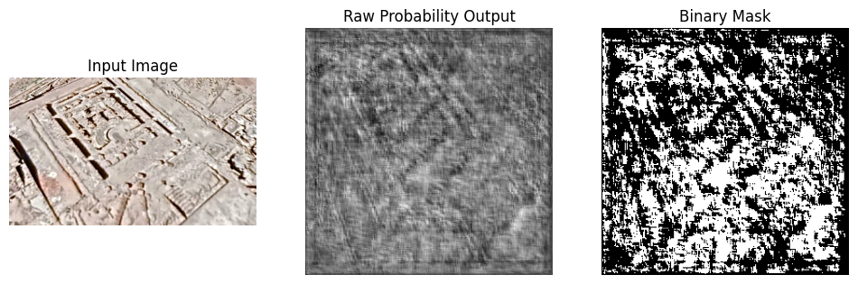

## Week 2

**1. Summary**

In Week 2, I focused on **Week-1 tasks** for the AI-Driven Archaeological Site Mapping project, specifically concentrating on **dataset collection.**. Key areas of work included:

* Understanding the correct dataset pipeline.
* Learning proper methods for collecting high-resolution archaeological imagery.
* Getting an introduction to the annotation workflow in Labelbox.

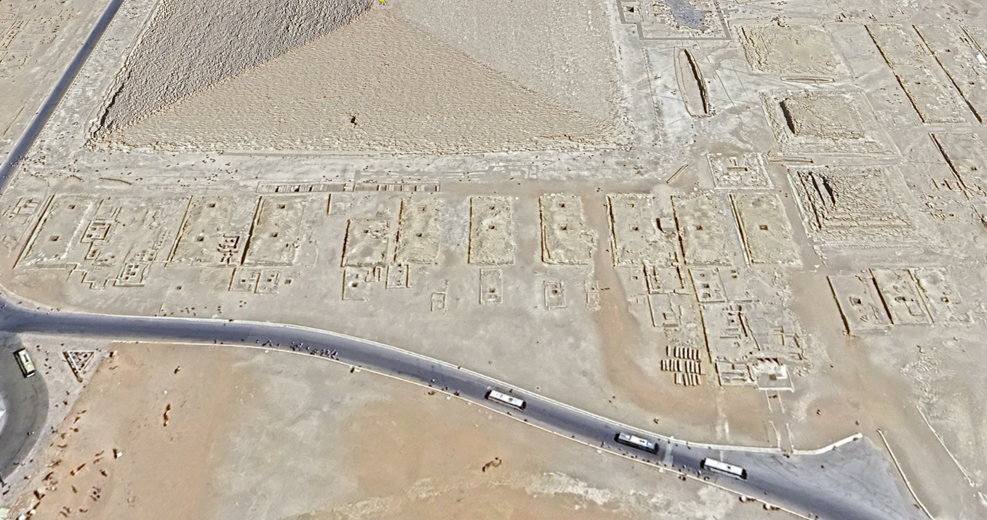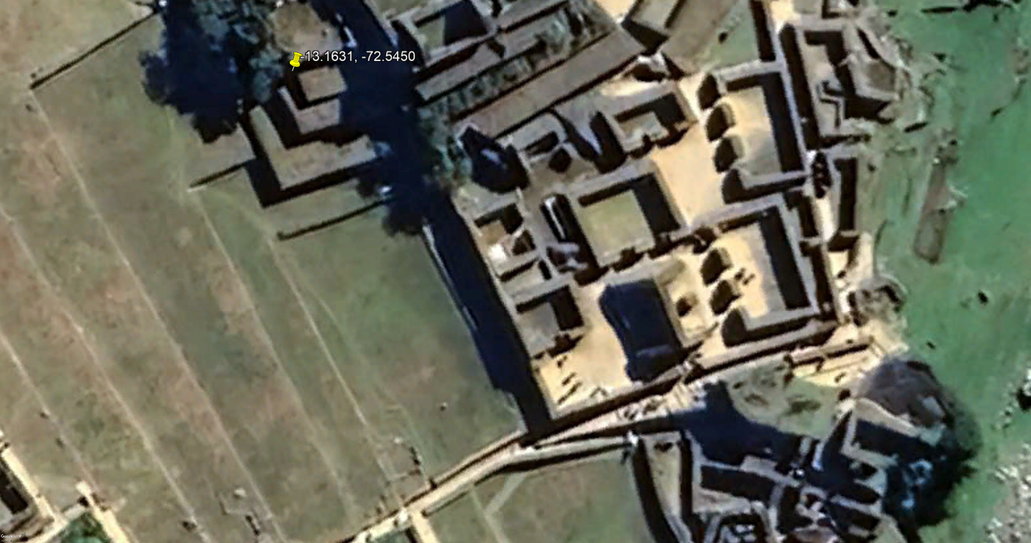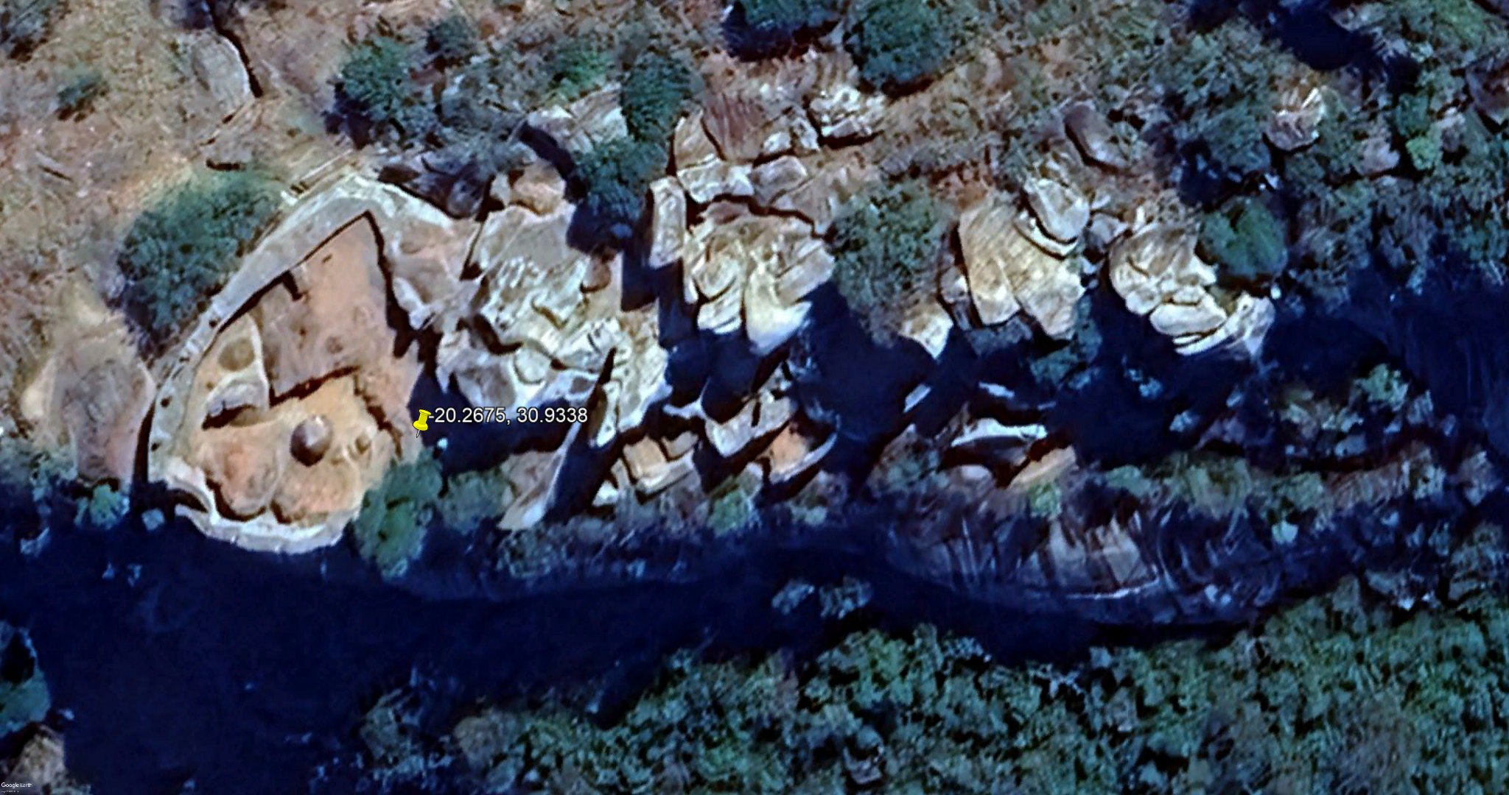

**2. Tasks Completed TodayDataset Collection Using Google Earth Pro**

* Identified and selected reliable archaeological sites (e.g., Petra, Hampi, Angkor Wat, Machu Picchu).
* Mastered the correct export settings in Google Earth Pro:
  + **Resolution:** 4800 px
  + **View:** Top-down (using the 'R' key)
  + **Zoom:** 20–30 m scale
* Successfully exported high-quality raw images essential for later segmentation and detection tasks.

**3. Labelbox Annotation Workflow**

I learned how to set up the necessary annotations for Week-2 tasks, defining the following **Segmentation classes**:

* ruins
* vegetation
* Background

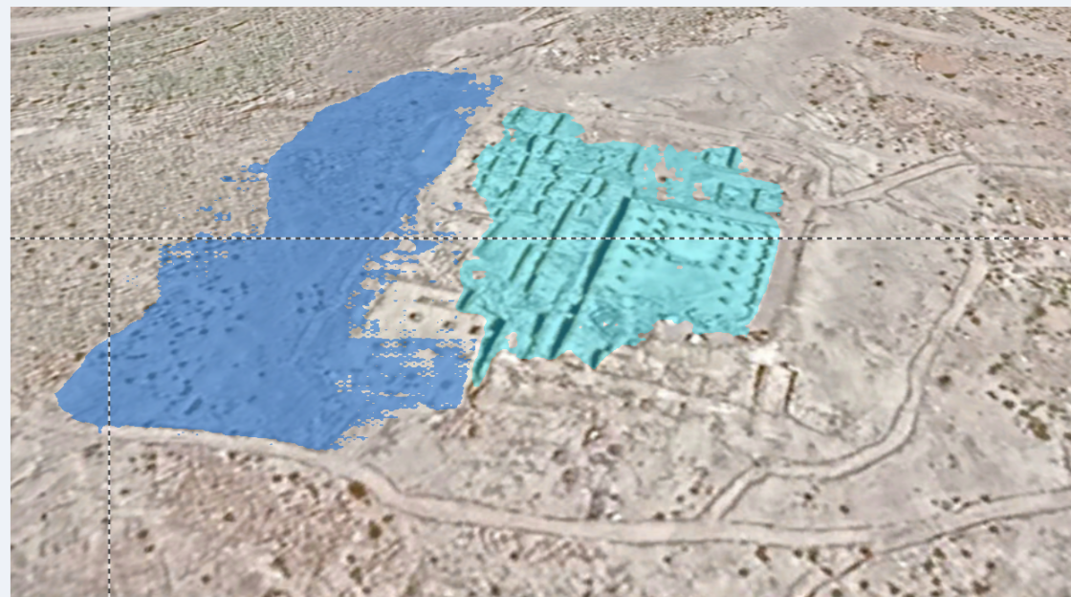

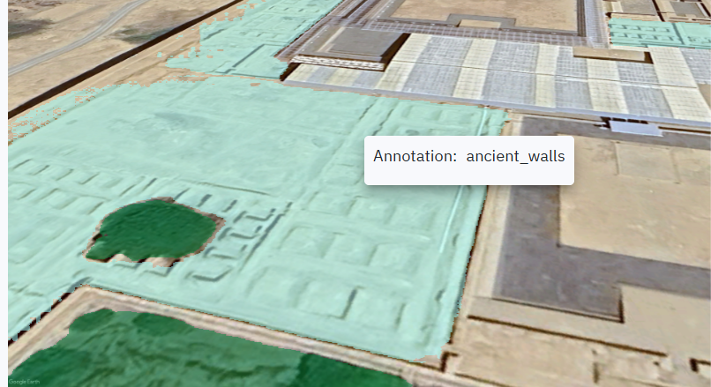

# WEEK 3 - Day 1

Archaeological sites across multiple regions (Peru, Mexico, Egypt, India, Middle East, Europe, Southeast Asia) were identified using **Google Earth Pro** with exact latitude-longitude coordinates for navigation. Images were captured at **high zoom levels** where walls, structural outlines, and terrain features were clearly visible, and saved at **maximum available resolution** to preserve spatial details.**Image Cropping**

Raw high-resolution images were **cropped into 512 × 512 pixel patches** before annotation. This ensured consistent input size for deep learning models and prevented loss of annotation accuracy. Care was taken **not to resize or stretch images**, preserving visual quality.**Annotation Preparation Strategy**

The following **annotation schema** was finalized before starting annotation:

## Semantic Segmentation Classes

| **Class ID** | **Class Name** |
| --- | --- |
| 0 | Background |
| 1 | Ruins |
| 2 | Vegetation |

## **Labelbox Annotation WorkTool Selection**

**Labelbox** was selected as the annotation platform for its:

* Polygon-based labeling support,
* Export compatibility with deep learning frameworks,
* Ease of dataset management.

**Annotation Process**

Cropped **512 × 512 satellite image patches** were uploaded to Labelbox. **Polygon annotations** were drawn for:

* Ruins (walls, building remnants, structural outlines),
* Vegetation (trees, shrubs, grass-covered areas).

Each polygon was assigned the appropriate class label, with a focus on **clarity and consistency**, avoiding ambiguous regions.

# WEEK 3 - Day 2

## Semantic Segmentation Annotation

* Annotated images using **Labelbox segmentation tools**.
* Defined segmentation classes:
  + **Ruins** (archaeological structures)
  + **Vegetation** (grass, shrubs, trees)
* Applied accurate pixel-level masks, strictly following archaeological boundaries.
* Ensured annotations were complete and properly saved.

## Labelbox Export Configuration

* Configured correct export settings:
  + Export labels from projects.
  + Included data row details.
  + Included label details only.
* Downloaded annotation data in **NDJSON format**.

## Annotation Conversion & Debugging

* Converted NDJSON export to standard JSON format.
* Identified that Labelbox provides **mask URLs instead of polygon geometry**.

## Mask Generation

* Successfully downloaded segmentation masks for each class.
* Merged class-wise masks into a **single-channel PNG mask** with the following encoding:
  + 0 → Background
  + 1 → Ruins
  + 2 → Vegetation
* Verified mask correctness by checking unique pixel values and visual overlays.

# WEEK 3 - Day 3

### **Dataset Upload to Labelbox**

* Created a **Labelbox project** titled *AI_site_mapping*
* Uploaded cropped images into a dataset named **“Ruin”**
* Verified image alignment, resolution, and consistency before annotation
* Annotated images using **Labelbox segmentation tools**
* Exported Annotated images as Json format

### **Mask Generation**

* Identified that Labelbox exports segmentation as mask URLs, not polygons
* Used authenticated API requests to download mask images
* Merged class-wise masks into a single PNG mask per image

## **Final Output**

A structured dataset ready for training a semantic segmentation model:

AI-site-mapping/

├── images/

│ └── 512×512 satellite images

├── masks/

│ └── PNG segmentation masks (background, ruins, vegetation)

# Week 3 - Day 4

**1. Data Preparation**

* Used high-resolution satellite images from **Google Earth**.
* The original image (approx. **4920 pixels**) was cropped into **144 smaller tiles**.
* All tiles were resized to a uniform **512 × 512 resolution**.
* Segmentation masks were cropped using the same tiling process to ensure **pixel-perfect alignment** with the images.

**2. Model Training**

* Implemented a **U-Net architecture** using **TensorFlow**.
* Loaded and fine-tuned pretrained model weights on the prepared dataset.
* The model was trained using annotated masks for:
  + Background
  + Ruins
  + Vegetation

**3. Model Evaluation**

The model’s performance was evaluated using **quantitative metrics** and **qualitative visual inspection**.**Quantitative Results**

* **Validation Accuracy:** 0.8836
* **Validation Dice Coefficient:** 0.8381
* **Validation Mean IoU:** 0.7299

These metrics demonstrate strong agreement between predicted segmentation masks and ground truth annotations.**Qualitative Evaluation**

* Segmentation maps were predicted for **five validation images**.
* Visual comparisons were generated, showing the:
  + Original input image
  + Ground truth mask
  + Model-predicted mask
* Visual inspection confirmed that the model successfully identified and segmented major archaeological structures and vegetation regions.

**Key Findings**

* The U-Net model's best weights were successfully loaded and applied.
* High Dice and IoU scores indicate effective learning and strong overlap between predictions and true masks.
* Predicted segmentation outputs were visually consistent with annotated ground truth masks.
* The model performed well across different validation samples, suggesting good generalization.

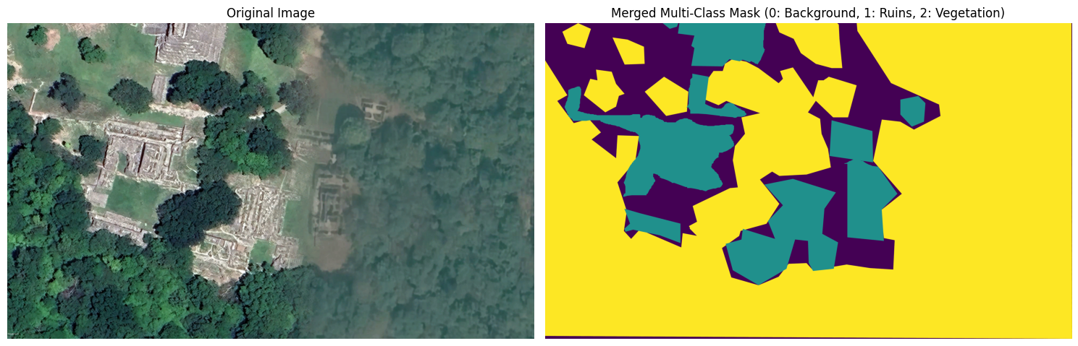

# Week 3 - day 5

## **Final Dataset Creation and Preprocessing**

### **1.Dataset Scale and Configuration**

The final dataset for the Semantic Segmentation model has been consolidated. The data aggregation phase is complete, resulting in a structured corpus of annotated satellite imagery optimized for training.

* **Base Dataset Volume:** 580 high-resolution satellite image patches.
* **Dimensions:** Fixed spatial resolution of 512 x 512 pixels.
* **Annotation Structure:** 580 corresponding pixel-aligned segmentation masks.
* **Class Encoding:** The masks utilize integer encoding for multi-class segmentation:

| **Class ID** | **Label** | **Description** |
| --- | --- | --- |
| **0** | Background | Non-relevant terrain/water bodies. |
| **1** | Ruins | Archaeological structures and remnants. |
| **2** | Vegetation | Trees, shrubs, and dense greenery. |

### 

### **2. Final Preprocessing & Splitting**

The augmented dataset underwent a final normalization and verification pass to ensure compatibility with the U-Net architecture.

* **Pixel Normalization**: All pixel intensities were scaled from [0, 255] to the floating-point range [0, 1] via linear scaling:
* **Tensor Shape Verification:**
  + **Input Images:** (N, 512, 512, 3)
  + **Target Masks:** (N, 512, 512, 1)

The dataset was partitioned using a stratified split to ensure class balance across both subsets.

| **Partition** | **Split Ratio** | **Sample Count** |
| --- | --- | --- |
| **Training Set** | 80% | 464 |
| **Validation Set** | 20% | *116* |
| **Total Dataset** | 100% | *580* |

### **Next Steps**

* **Model Initialization:** Load U-Net backbone (with/without pre-trained encoder weights).
* **Hyperparameter Tuning:** Define learning rate schedulers and loss functions (e.g., Sparse Categorical Crossentropy or Dice Loss).
* **Training Loop:** Begin Epoch 1.

Week 4 - Day 1 : Checkpoint

# **Archaeological Site Segmentation Using U-Net**

## **1. Introduction**

The objective of this project is to automatically identify and segment archaeological features from aerial or satellite images using deep learning. Manual identification of archaeological sites is time-consuming and error-prone. Hence, an automated image segmentation approach can assist researchers by accurately highlighting regions of interest such as ruins and structures.

To achieve this, a **semantic segmentation model** based on the **U-Net architecture** was implemented using **PyTorch**. The model classifies each pixel of an image into predefined classes, enabling precise localization of archaeological features.

## **2. Dataset Description**

The dataset consists of:

* **580 original images** (RGB)
* **580 corresponding mask images**
* Image size: **512 × 512**
* Each mask contains **three classes**:  
  + Class 0: Background
  + Class 1: Ruins
  + Class 2: Vegetation

Each image has a one-to-one correspondence with its segmentation mask, ensuring accurate supervised learning.

## **3. Data Preprocessing and Augmentation**

To prepare the data for training, the following preprocessing steps were applied:

### **3.1 Image Loading**

* Images were read using OpenCV and converted from BGR to RGB format.
* Masks were loaded as grayscale images representing class indices.

### **3.2 Normalization**

Since a pretrained encoder was used, images were normalized using **ImageNet statistics**:

* Mean: (0.485, 0.456, 0.406)
* Standard deviation: (0.229, 0.224, 0.225)

This ensures compatibility with pretrained weights.

### **3.3 Data Augmentation**

To improve generalization and reduce overfitting, the following augmentations were applied to training images:

* Horizontal and vertical flipping
* Rotation
* Brightness and contrast variation
* Gaussian blur

No augmentation was applied to validation data to ensure fair evaluation.

## **4. Dataset Splitting and Data Loading**

The dataset was split into:

* **Training set**: Used for model learning
* **Validation set**: Used for performance evaluation on unseen data

DataLoader objects were used to:

* Load data in batches
* Shuffle training data
* Improve training efficiency

Each epoch consisted of **116 batches**, covering the entire training dataset once.

## **5. Model Architecture**

### **5.1 U-Net Architecture**

The model is based on the **U-Net architecture**, which consists of:

* An **encoder** that extracts hierarchical features
* A **decoder** that reconstructs pixel-level segmentation maps
* **Skip connections** that preserve spatial details

### **5.2 Pretrained Encoder**

A **ResNet-34 encoder pretrained on ImageNet** was used to:

* Accelerate convergence
* Improve feature extraction
* Achieve higher accuracy with limited data

The model outputs a multi-class segmentation map with three classes.

## **6. Loss Functions**

To handle class imbalance and improve segmentation quality, a **combined loss function** was used:

* **Dice Loss**: Measures overlap between predicted and ground truth masks
* **Focal Loss**: Focuses learning on hard-to-classify pixels

This combination ensures both region accuracy and boundary precision.

## **7. Optimization and Training Strategy**

### **7.1 Optimizer**

* **AdamW optimizer** was used for stable and efficient optimization.
* Weight decay was applied to reduce overfitting.

### **7.2 Learning Rate Scheduler**

* **ReduceLROnPlateau** scheduler automatically reduced the learning rate when validation performance stopped improving.

### **7.3 Mixed Precision Training**

* Automatic Mixed Precision (AMP) was used to:  
  + Reduce GPU memory usage
  + Speed up training
  + Maintain numerical stability

## **8. Evaluation Metrics**

Traditional accuracy is not suitable for segmentation due to class imbalance. Therefore, the following metrics were used:

* **Intersection over Union (IoU)**: Measures spatial overlap between prediction and ground truth
* **Dice Score**: Measures similarity between predicted and true masks

IoU was used as the primary evaluation metric.

**9. Training Results**

The model was trained for **50 epochs**, and the best-performing checkpoint was saved based on validation IoU.

## **Model Output:**

**Prediction from validation set**

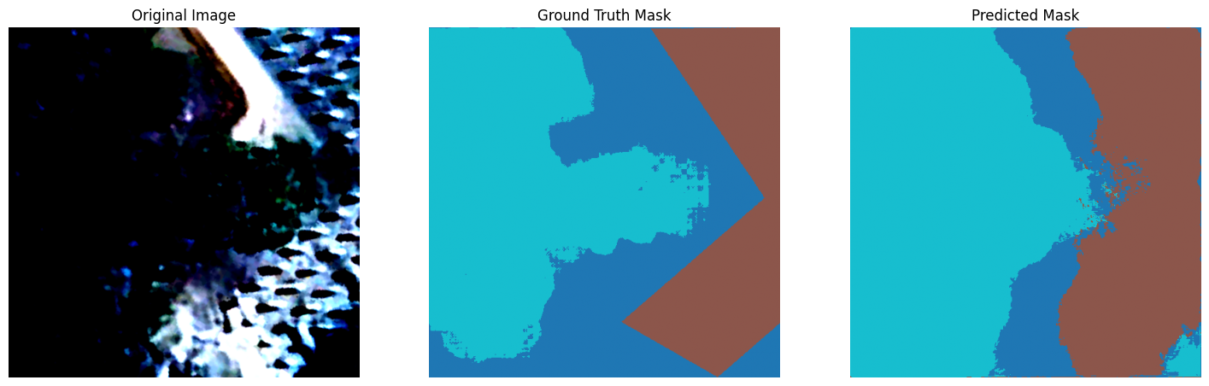

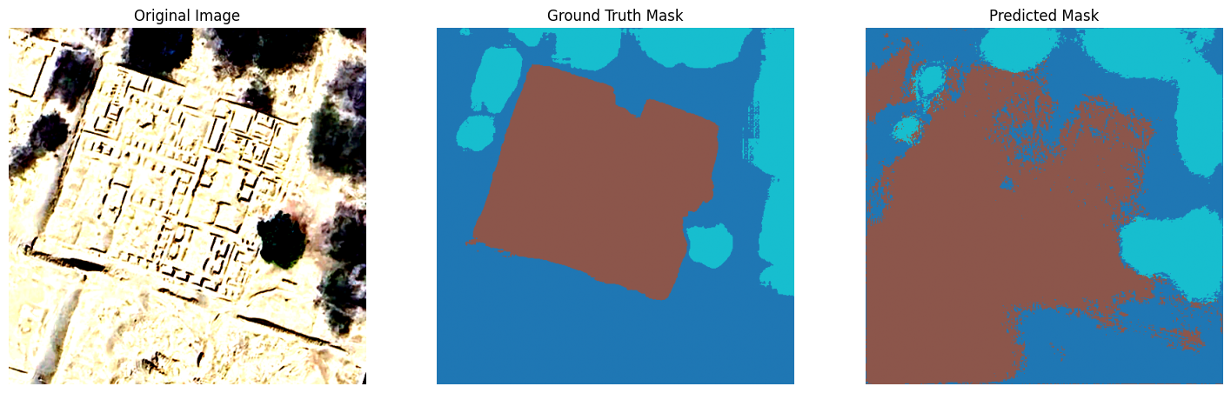

**Predictions from uploaded images:**

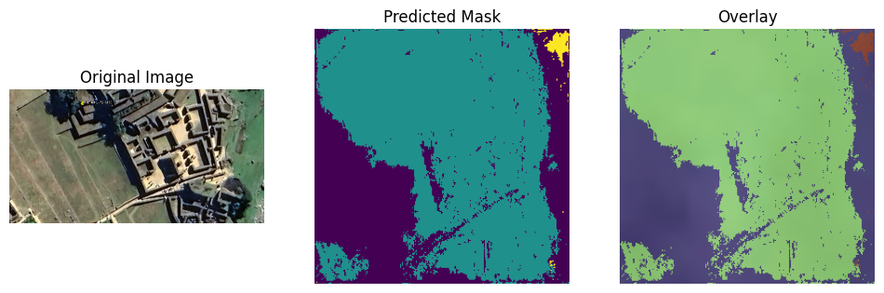

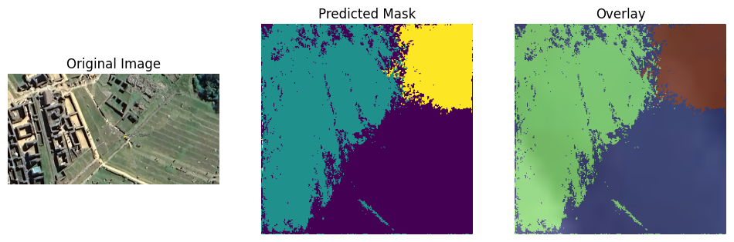

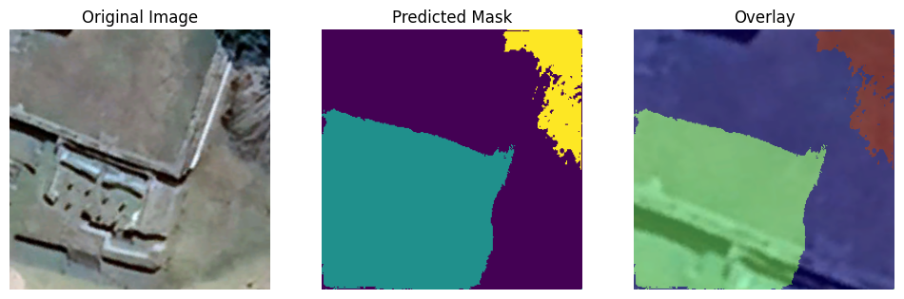

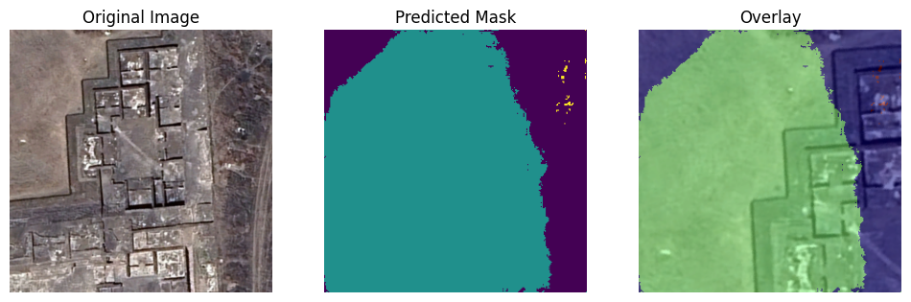

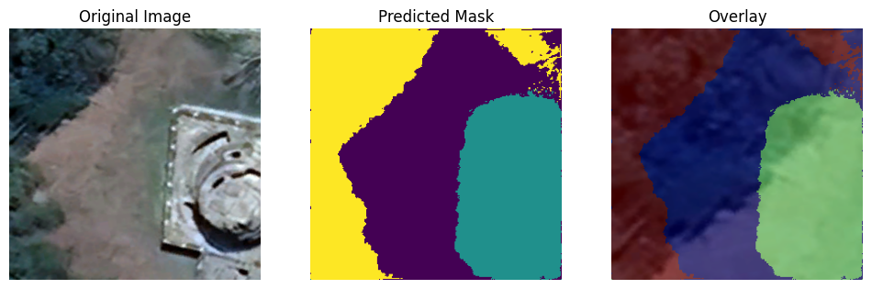

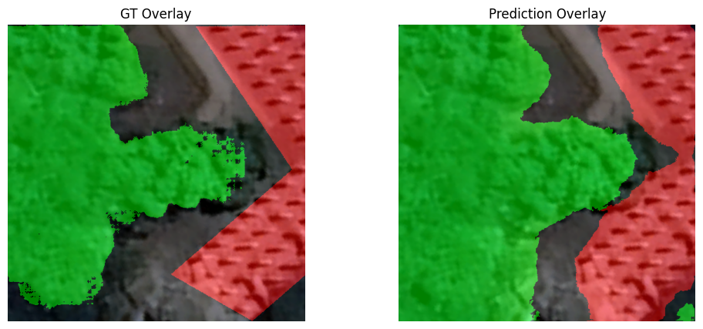

### **Best Performance Achieved:**

* **Mean Validation IoU**: **0.5969**
* **Mean Validation Dice**: **0.5926**
* **Per-Class IoU**:  
  + Background (Class 0): 0.4257
  + Ruins(Class 1): 0.6116
  + Vegetation (Class 2): 0.7233

The results show strong performance on foreground classes, which are the primary focus of the project.

## **10. Model Validation and Generalization**

The validation results demonstrate that:

* Training loss consistently decreased
* Validation IoU stabilized around 0.6
* The model generalizes well to unseen images

Fluctuations in validation IoU were expected due to dataset size and augmentation randomness.

## **11. Conclusion**

This project successfully demonstrates the application of deep learning for archaeological site segmentation. By combining a U-Net architecture with a pretrained encoder, advanced data augmentation, and class-balanced loss functions, the model achieved reliable segmentation performance.

The final model provides accurate pixel-level predictions and can assist archaeological research by automating site detection and analysis.

# Week 4 - Day 2

* Prepare YOLO-specific dataset structure.Trained a **segmentation model** to identify **ruins and vegetation** in aerial images.
* **Segmentation vs. Object Detection (YOLO) Clarification:**
  + Segmentation provides pixel-level masks.
  + YOLO uses bounding boxes for objects (e.g., ruins, artifacts).
* **Dataset Insights:**
  + YOLO class names are derived from the dataset, not the model.
  + The **TimeTravel dataset** is suitable for classification but lacks bounding boxes for object detection. <https://huggingface.co/datasets/MBZUAI/TimeTravel>
  + Segmentation masks require conversion before use with YOLO.

**Key Learning**

* Artifact detection demands **closer, higher-resolution images** compared to satellite vegetation mapping.
* Model accuracy improves primarily through:
  + Training with **more diverse images**.
  + **Fine-tuning** an existing model rather than training from scratch.

**Next Steps**

* Finalize object detection classes.
* **Collect or annotate images to create YOLO bounding boxes.**
* Improve segmentation accuracy using more data and augmentation.
* Prepare the YOLO-specific dataset structure.

# Week 4 - day 3

### **Key Progress Today**

1. **Dataset Download & Storage**
   * Downloaded **over 10,000 artifact images** from a Hugging Face dataset.
   * Organized and stored the images in **Google Drive** for further processing.
2. **Metadata Exploration**
   * Analyzed the dataset metadata file to understand available fields such as artifact description, materials, subjects, culture, and image references.
   * Identified which metadata fields could be used to infer **artifact types**.
3. **Artifact Type Classification**
   * Classified images into **artifact categories** including coin, jewelry, pottery, tablet, sculpture, weapon, architectural objects, tools, seals, textiles, and masks.
   * Created a mapping between images and their corresponding artifact types.
4. **Class Distribution Analysis**
   * Computed the **number of images per artifact class** to analyze dataset balance.
   * Identified highly imbalanced classes, with some categories having thousands of images and others having very few samples.
5. **Dataset Reduction Planning**
   * Decided to **downsample overrepresented classes** and exclude classes with insufficient samples.
   * Defined a reduced and balanced set of artifact classes suitable for **YOLO-based object detection training**.

# **Week 4 – Day 5 Report**

Project Title: AI-Driven Archaeological Site Mapping

Milestone: Milestone 2 – Segmentation and Object Detection Models

Module Focus:

* Module 4: Object Detection and Classification of Artifacts
* Module 6: Model Evaluation and Tuning

## **Objective**

To implement and evaluate an object detection and classification pipeline for identifying archaeological artifacts using deep learning, and to analyze model performance and convergence behavior as part of the archaeological site mapping workflow.

## **Tasks Performed**

### **1. Artifact Classification Model Implementation**

* Implemented a YOLOv8-based image classification model (YOLOv8n-cls) using the Ultralytics framework.
* Configured the model to classify 7 artifact-related classes derived from the archaeological dataset.
* Leveraged ImageNet-pretrained weights to improve convergence on limited archaeological imagery.

### **2. Dataset Preparation and Validation**

* Used a curated dataset split into:  
  + Training set: 1195 images
  + Validation set: 147 images
  + Test set: 155 images
* Verified dataset integrity and class balance.
* Ensured compatibility with YOLO classification directory structure.

### **3. Model Training**

* Trained the model on Google Colab with Tesla T4 GPU.
* Key training parameters:  
  + Image size: 64 × 64
  + Batch size: 16
  + Optimizer: AdamW (auto-selected)
  + Epochs: 50
  + Automatic Mixed Precision (AMP): Enabled
* Training executed successfully without instability or runtime errors.

### **4. Model Evaluation**

* Monitored performance using Top-1 and Top-5 accuracy metrics.
* Observed rapid convergence within the first few epochs.
* Best validation performance achieved at Epoch 16.

#### **Performance Results:**

* Best Top-1 Accuracy: 95.2%
* Stable Validation Accuracy: ~93–94%
* Top-5 Accuracy: ~99–100%

## **Analysis**

* The model demonstrated strong feature learning due to pretrained initialization.
* Early saturation of accuracy indicates model capacity and resolution constraints.
* Performance fluctuations after convergence are attributed to:  
  + Small validation dataset
  + Low input image resolution
* The trained classifier is suitable for artifact categorization, forming a key component of the archaeological object detection pipeline.

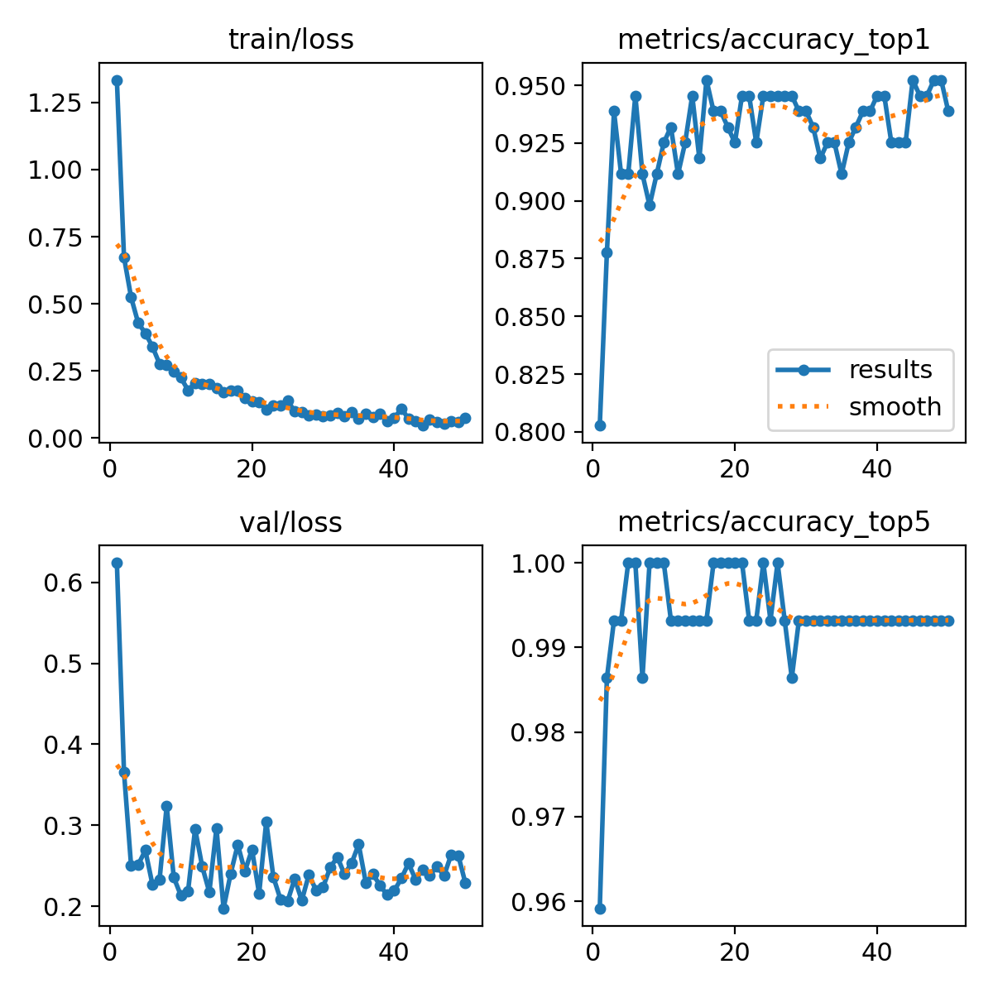

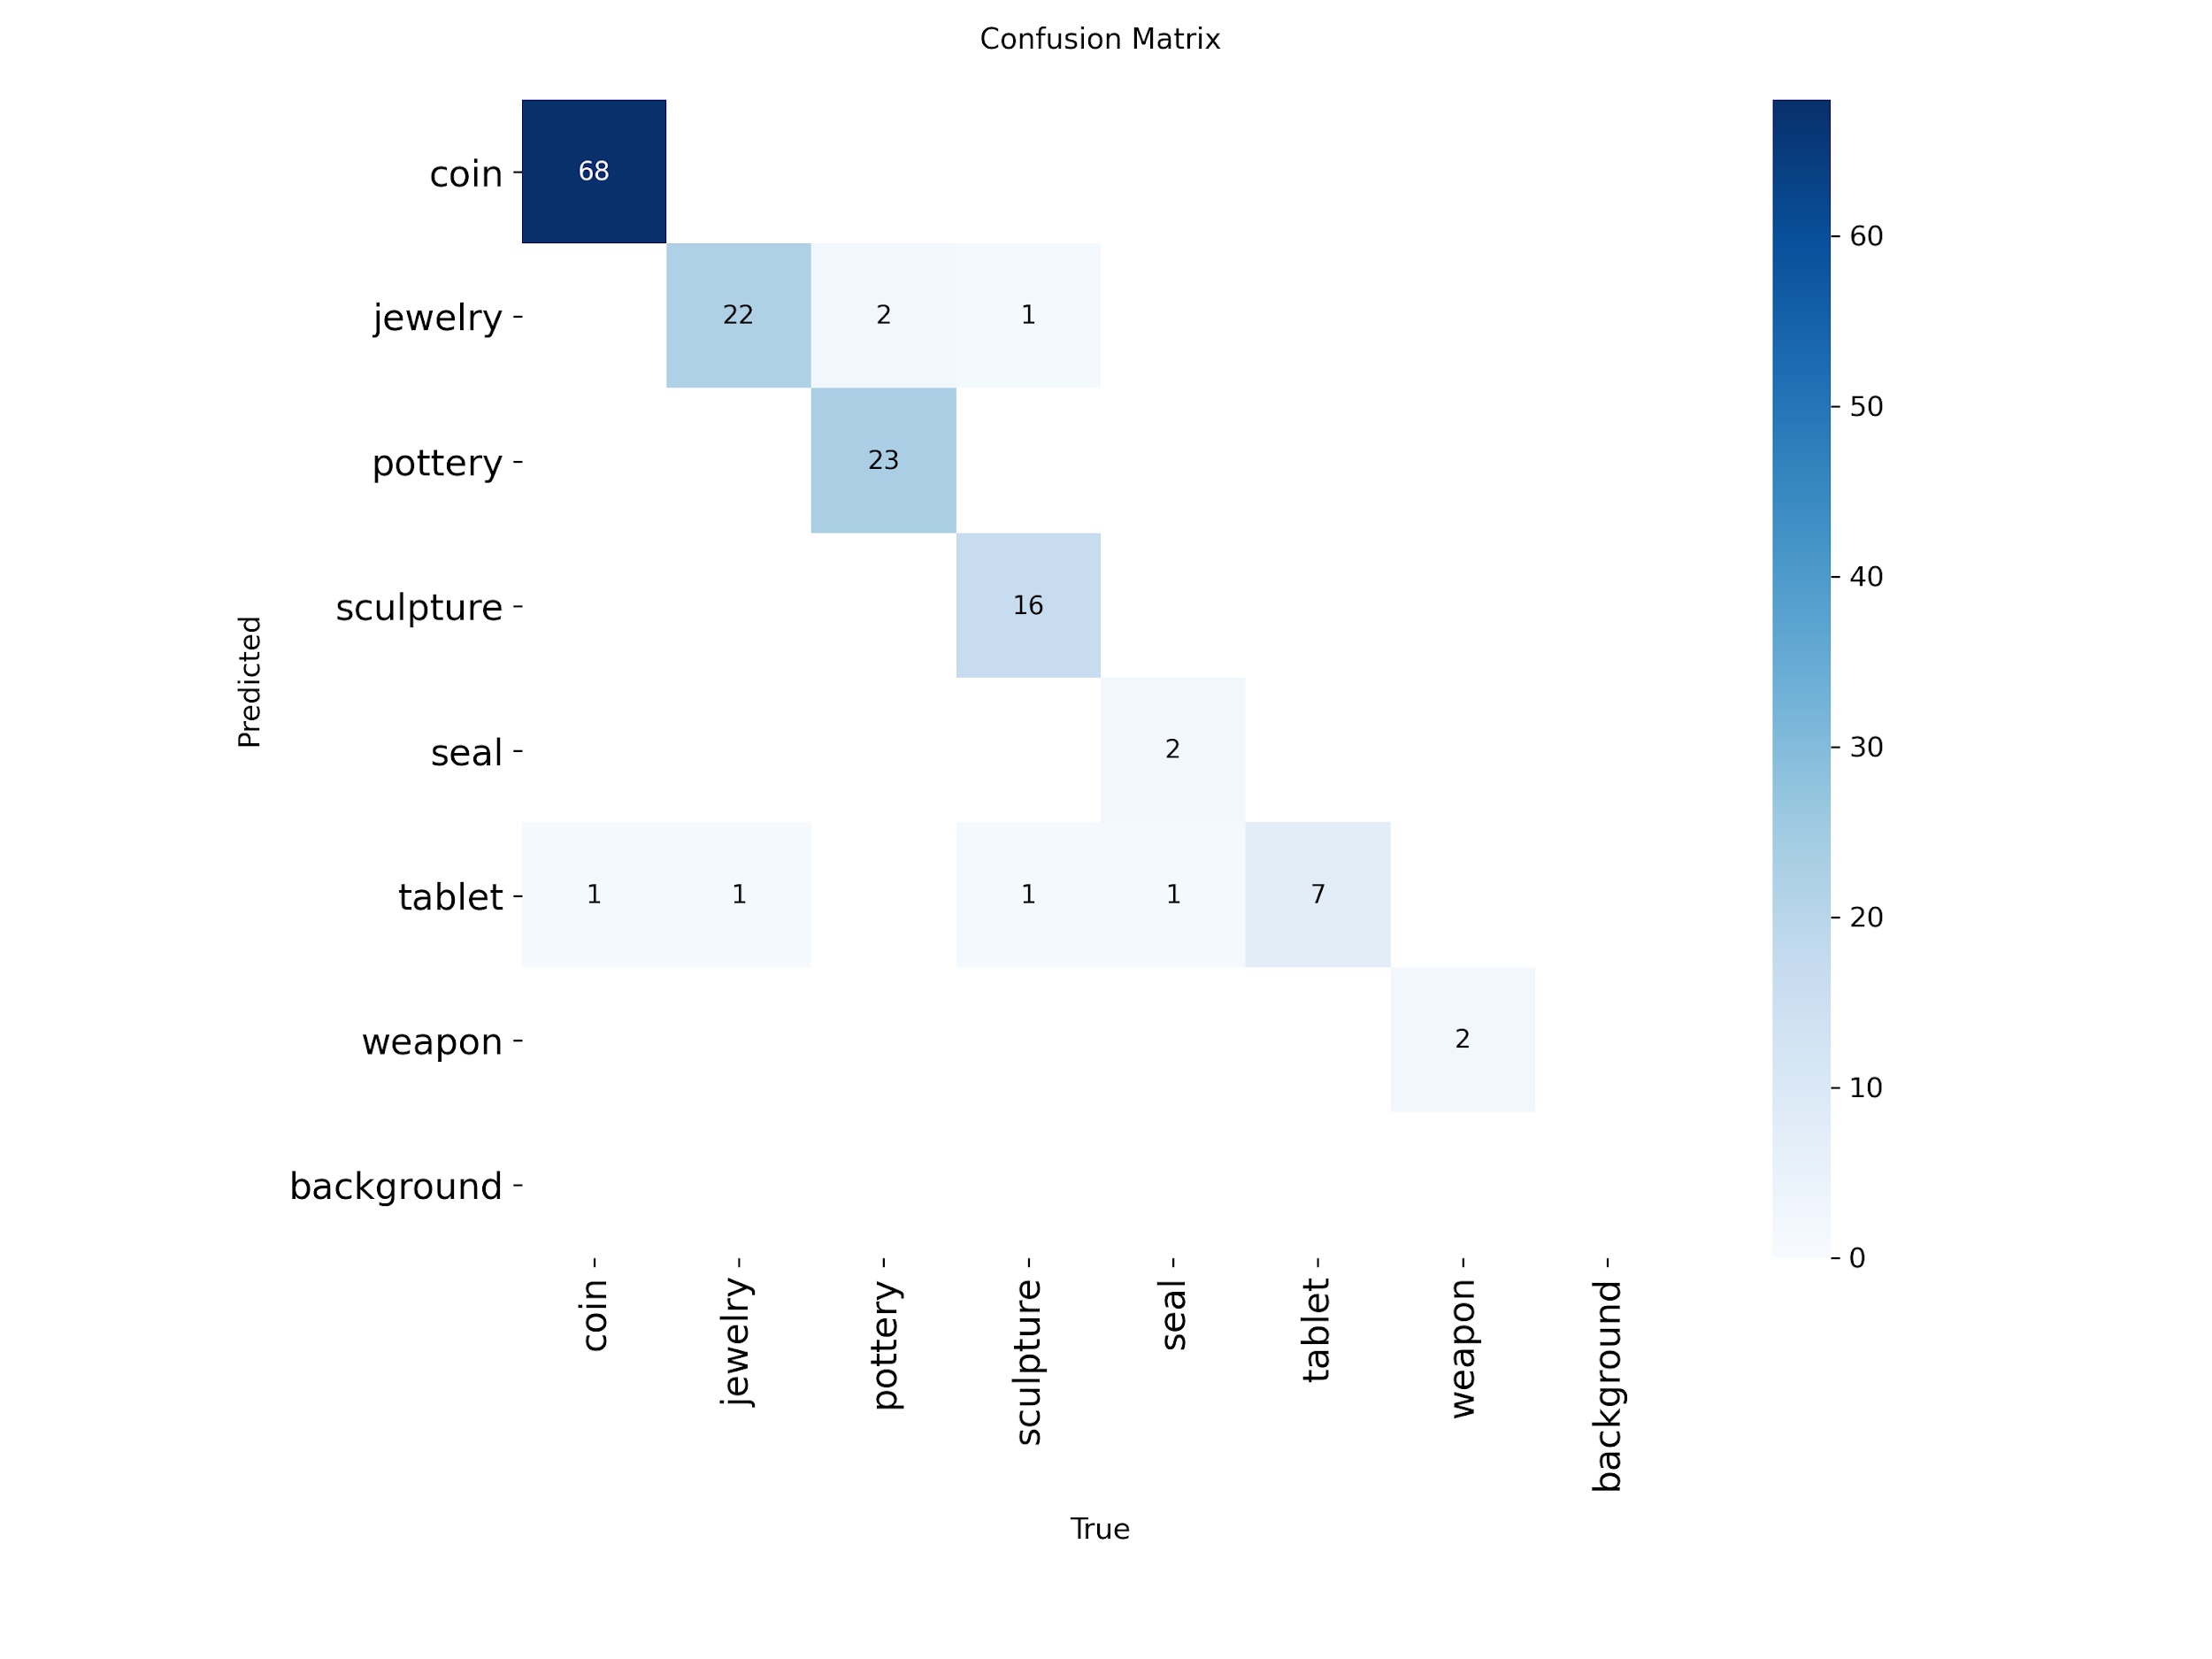

## **Conclusion**

The YOLOv8 classification model was successfully trained and evaluated for artifact classification. The achieved accuracy satisfies the requirements of Milestone 2, and the model can be integrated with object detection outputs to support archaeological site analysis. Further improvements can be achieved by increasing input resolution or model size.

# **Week 5 – Summary Report**

Milestone: Milestone 3 – Terrain Erosion Prediction (Initiation Phase)

Associated Modules:

* Module 5: Terrain Erosion Prediction Model
* Module 6: Model Evaluation and Tuning

## **Overview**

Week 5 focused on transitioning from visual artifact analysis to environmental risk assessment, a critical step in AI-driven archaeological site mapping. Emphasis was placed on understanding how terrain and vegetation characteristics influence site degradation and erosion.

## **Key Activities**

### **1. Conceptual Design of Erosion Prediction Pipeline**

* Studied terrain-based features relevant to archaeological erosion:  
  + Slope
  + Elevation
  + Vegetation density
  + Surface irregularities
* Defined erosion classification objectives:  
  + Erosion-prone areas
  + Stable regions

### **2. Data Preparation Planning**

* Planned integration of:  
  + Segmentation outputs (ruins & vegetation)
  + Terrain features derived from satellite imagery
* Prepared dataset structure suitable for:  
  + XGBoost
  + Random Forest models

### **3. Model Selection and Evaluation Strategy**

* Selected tree-based regression/classification models due to:  
  + Interpretability
  + Suitability for geospatial features
* Finalized evaluation metrics:  
  + RMSE – prediction error
  + R² Score – model fit and reliability

### **4. Integration Perspective**

* Established the relationship between:  
  + Segmentation (ruins & vegetation)
  + Artifact detection/classification
  + Terrain erosion prediction
* Outlined future integration into a map-based dashboard for archaeologists.

## **Week 6 Progress Report**

### **Objectives**

* Finalize Milestone 2 implementation
* Evaluate segmentation and artifact recognition models
* Analyze model performance and limitations

### **Work Completed**

* Successfully trained a U-Net segmentation model for identifying ruins and vegetation from aerial imagery.
* Evaluated segmentation performance using standard metrics:  
  + Mean IoU
  + Dice coefficient
  + Class-wise IoU
* Implemented YOLOv8n-cls (classification) for archaeological artifact recognition.
* Prepared a multi-class dataset containing artifact categories such as:  
  + Coin, jewelry, pottery, sculpture, seal, tablet, and weapon
* Completed dataset splitting (train/validation/test) and model training using transfer learning.

### **Results Summary**

* U-Net Segmentation  
  + Mean Validation Dice: 0.5926
  + Mean Validation IoU: 0.5869
  + Strong performance on vegetation and major ruin regions
* YOLO Artifact Classification  
  + Top-1 Accuracy: 95.24%
  + Top-5 Accuracy: 99.32%
  + Demonstrated strong generalization across artifact classes

### **Key Observations**

* Segmentation is effective for large-scale ruin detection.
* YOLO classification performs well but does not provide object localization.
* Dataset quality and class balance strongly influence results.

## **Week 7 Progress Report**

### **Objectives**

* Begin Milestone 3: Terrain and Risk Prediction
* Transition from image-based models to tabular geospatial learning
* Integrate environmental datasets (DEM, NDVI, slope, landslide)

### **Work Completed**

* Collected and analyzed open-source geospatial datasets:  
  + Smoothed DEM
  + Landslide susceptibility dataset
  + Slope stability dataset
  + NDVI-based environmental data
* Prepared CSV-based datasets for machine learning.
* Designed a terrain prediction pipeline using numerical features.
* Implemented feature selection and preprocessing in Google Colab.
* Selected Random Forest–based models for erosion / stability prediction.

### **Dataset Summary**

* Total samples: 580
* Training samples: 464
* Validation samples: 116
* Features used:  
  + Elevation (DEM)
  + NDVI
  + Slope
  + Rainfall / stability indicators

### **Key Observations**

* NDVI and slope are dominant factors in terrain risk prediction.
* Tabular ML models are more suitable than CNNs for this milestone.
* Milestone 3 complements visual detection by adding environmental risk analysis.